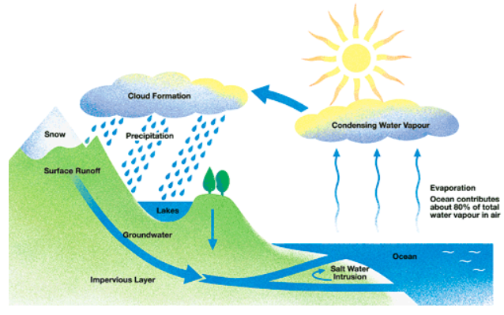

The picture illustrates the way in which water passes from ocean to air to land during the natural process known as the water cycle.

Three main stages are shown on the diagram. Ocean water evaporates, falls as rain, and eventually runs back into the ocean again.

Beginning at the evaporation stage, we can see that 80% of total water vapour in the air comes from the oceans. Heat from the sun causes water to evaporate, and water vapour condenses to form clouds. At the second stage, labelled ‘precipitation’ on the diagram, water falls as rain or snow.

At the third stage in the cycle, rainwater may take various paths. Some of it may fall into lakes or return to the oceans via ‘surface runoff’. Otherwise, rainwater may filter through the ground, reaching the impervious layer of the earth. Salt water intrusion is shown to take place just before groundwater passes into the oceans to complete the cycle.

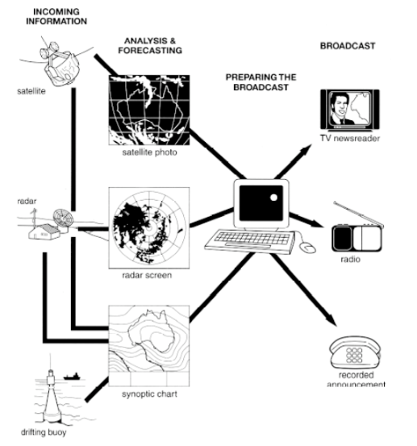

The figure illustrates the process used by the Australian Bureau of Meteorology to forecast the weather.

There are four stages in the process, beginning with the collection of information about the weather. This information is then analysed, prepared for presentation, and finally broadcast to the public.

Looking at the first and second stages of the process, there are three ways of collecting weather data and three ways of analyzing it. Firstly, incoming information can be received by satellite and presented for analysis as a satellite photo. The same data can also be passed to a radar station and presented on a radar screen or synoptic chart. Secondly, incoming information may be collected directly by radar and analysed on a radar screen or synoptic chart. Finally, drifting buoy also receive data which can be shown on a synoptic chart.

At the third stage of the process, the weather broadcast is prepared on computers. Finally, it is delivered to the public on television, on the radio, or as a recorded telephone announcement.

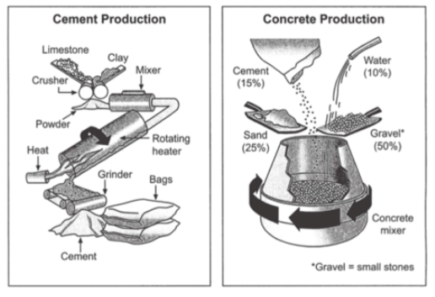

The first diagram illustrates the process of cement manufacture, and the second diagram shows the materials that go into the production of concrete.

It is clear that there are five stages in the production of cement, beginning with the input of raw materials and ending with bags of finished product. To produce concrete, four different materials are mixed together.

At the first stage in the production of cement, limestone and clay are crushed to form powder. This powder is then mixed before it passes into a rotating heater. After heating, the resulting mixture is grinded, and cement is produced. Finally, the cement is packaged in large bags.

Cement is one of the four raw materials that are used in the production of concrete, along with gravel, sand and water. To be exact, concrete consists of 50% gravel, 25% sand, 15% concrete and 10% water. All four materials are blended together in a rotating machine called concrete mixer.

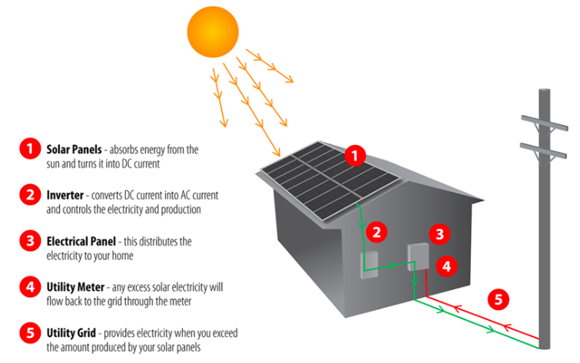

The picture illustrates the process of producing electricity in a home using solar panels.

It is clear that there are five distinctive stages in this process, beginning with the capture of energy from sunlight. The final two steps show how domestic electricity is connected to the external power supply.

At the first stage in the process, solar panels on the roof of a normal house take energy from the sun and convert it into DC current. Next, this current is passed to an inverter, which changes it to AC current and regulates the supply of electricity. At stage three, electricity is supplied to the home from an electrical panel.

At the fourth step shown on the diagram, a utility mater in the home is responsible for sending any extra electric power outside the house into the grid. Finally, if the solar panels do not provide enough energy for the household, electricity will flow from the utility grid into the home through the meter.